**ASSIGNMENT NO.2**

**HR DATABASE EXERCISE**

1. Write a query to display the names (first_name, last_name) using alias name “First Name", "Last Name"

Query :

select first_name as 'First Name',last_name as 'Last Name' from employees;

Output:

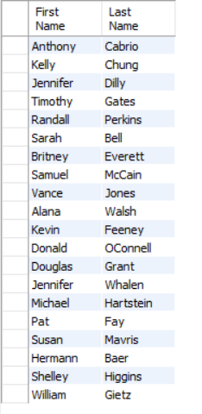

1. Write a query to get unique department ID from employee table

Query:

select distinct department_id from employees;

Output:

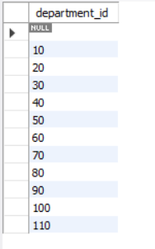

1. Write a query to get all employee details from the employee table order by first name, descending

Query:

select * from employees order by first_name desc;

Output:

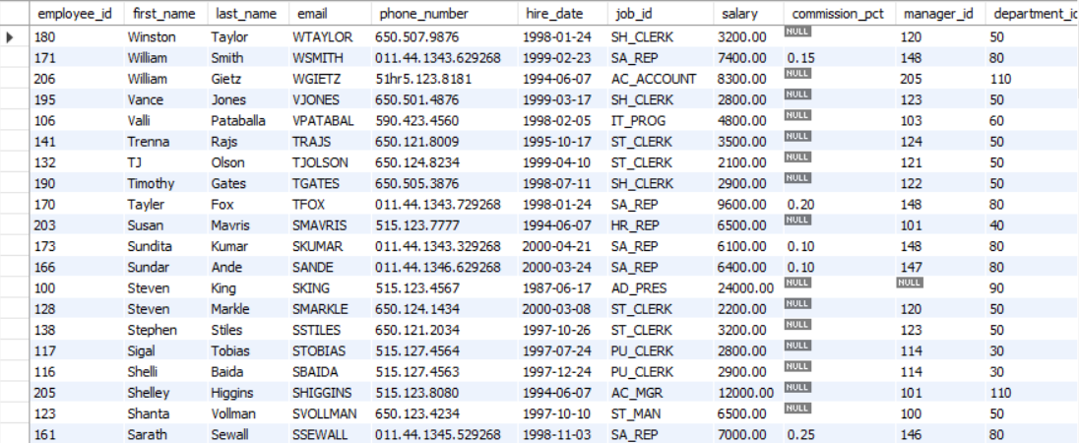

1. Write a query to get the names (first_name, last_name), salary, PF of all the employees (PF is calculated as 15% of salary)

Query:

select first_name,last_name,salary,salary*.15 PF from employees;

Output:

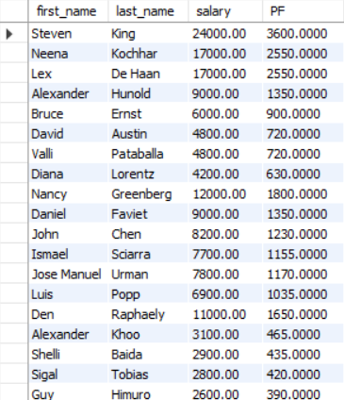

1. Write a query to get the employee ID, names (first_name, last_name), salary in ascending order of salary

Query:

select employee_id,first_name,last_name,salary from employees order by salary;

Output:

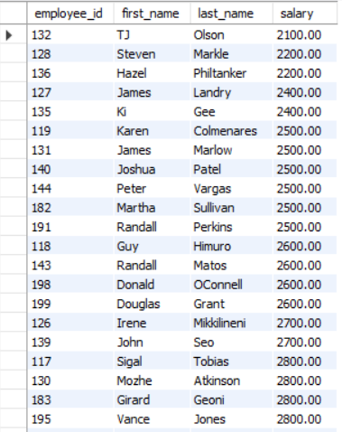

1. Write a query to get the total salaries payable to employees

Query:

select sum(salary) from employees;

Output:

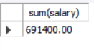

1. Write a query to get the maximum and minimum salary from employees table

Query:

select max(salary),min(salary) from employees;

Output:

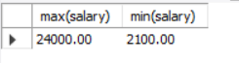

1. Write a query to get the average salary and number of employees in the employees table

Query:

select avg(salary),count(employee_id)as number_of_employees from employees;

Output:

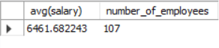

1. Write a query to get the number of employees working with the company

Query:

select count(*)from employees;

Output:

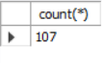

Query:

select count(*) as no_of_employees from employees;

Output:



1. Write a query to get the number of jobs available in the employees table

Query:

select count(job_id) from employees;

Output:



1. Write a query get all first name from employees table in upper case

Query:

select upper(first_name) from employees;

Output:

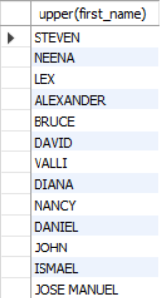

1. Write a query to get the first 3 characters of first name from employees table

Query:

select left(first_name,3) from employees;

Output:

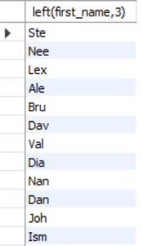

1. Write a query to get first name from employees table after removing white spaces from both side

Query:

select trim(first_name) from employees;

Output:

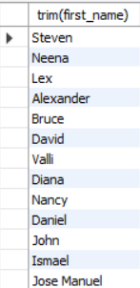

1. Write a query to get the length of the employee names (first_name, last_name) from employees table

Query:

select first_name,last_name,length(first_name)+length(last_name) "length of name" from employees;

Output:

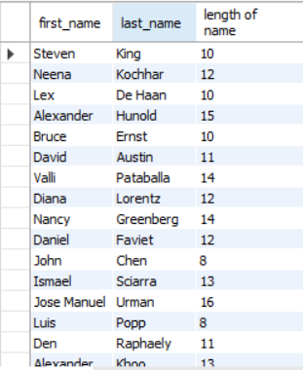

1. Write a query to check if the first_name fields of the employees table contains numbers

Query:

1. Write a query to display the name (first_name, last_name) and salary for all employees whose salary is not in the range $10,000 through $15,000

Query:

select first_name,last_name,salary from employees where salary not between 10000 and 15000 ;

Output:

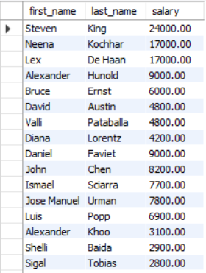

1. Write a query to display the name (first_name, last_name) and department ID of all employees in departments 30 or 100 in ascending order

Query:

select first_name,last_name,department_id from employees where department_id IN(30,100) order by department_id;

Output:

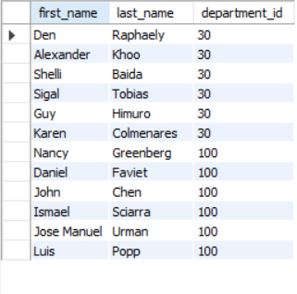

1. Write a query to display the name (first_name, last_name) and salary for all employees whose salary is not in the range $10,000 through $15,000 and are in department 30 or 100

Query:

select first_name,last_name,salary,department_id from employees where salary not between 10000 and 15000 and department_id in(30,100);

Output:

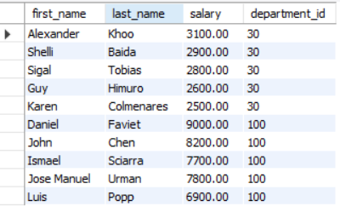

1. Write a query to display the name (first_name, last_name) and hire date for all employees who were hired in 1987

Query:

select first_name,last_name,hire_date from employees where year (hire_date) like'1987';

Output:

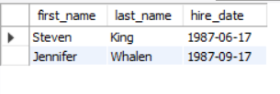

1. Write a query to display the first_name of all employees who have both "b" and "c" in their first name

Query:

select first_name from employees where first_name like '%b%' and first_name like '%c%';

Output:



1. Write a query to display the last name, job, and salary for all employees whose job is that of a Programmer or a Shipping Clerk, and whose salary is not equal to $4,500, $10,000, or $15,000

Query:

Select last_name,job_id,salary from employees where job_id in ('IT_PROG','SH_clerk')and salary not in (4500,10000,15000);

Output:

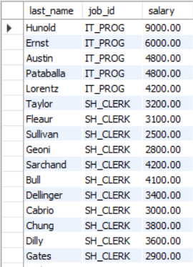

1. Write a query to display the last name of employees whose names have exactly 6 characters

Query:

select last_name from employees where last_name like '______';

Output:

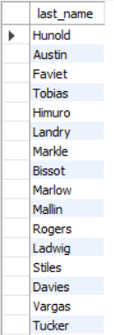

1. Write a query to display the last name of employees having 'e' as the third character

Query:

select last_name from employees where last_name like '__e%';

Output:

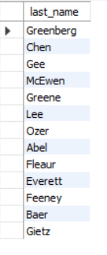

1. Write a query to get the job_id and related employee's id Partial output of the query :

job_id Employees ID AC_ACCOUNT206 AC_MGR 205 AD_ASST 200 AD_PRES 100 AD_VP 101 ,102 FI_ACCOUNT 110 ,113 ,111 ,109 ,112

Query:

select job_id,group_concat(employee_id, ' ') 'Employee Id' from employees group by job_id;

Output:

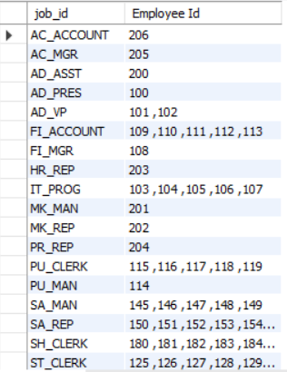

1. Write a query to update the portion of the phone_number in the employees table, within the phone number the substring '124' will be replaced by '999'

Query:

28. Write a query to extract the last 4 character of phone numbers

Query:

select right(phone_number,4) as 'phone no' from employees;

Output:

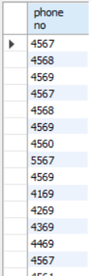

30. Write a query to get the locations that have minimum street length

Query:

select * from locations where length(street_address)<=(select min(length(street_address))from locations);

Output:

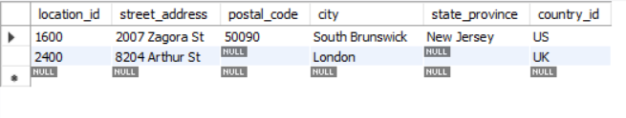

31. Write a query to display the first word from those job titles which contains more than one words

Query:

select job_title,substr(job_title,1,instr(job_title,' ')-1) from jobs;

Output:

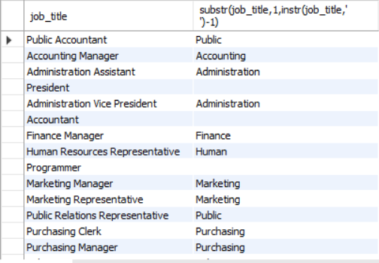

32. Write a query to display the length of first name for employees where last name contain character 'c' after 2nd position

Query:

select first_name,last_name from employees where instr(last_name,'c')>2;

Output:

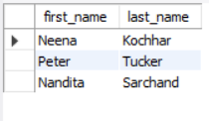

33.

Write a query that displays the first name and the length of the first name for all employees whose name starts with the letters 'A', 'J' or 'M'. Give each column an appropriate label. Sort the results by the employees' first names

Query:

select first_name 'Employee name',length(first_name)'length'

from employees

where first_name like 'A%' or first_name like 'J%' or first_name like'M%'

order by first_name;

Output:

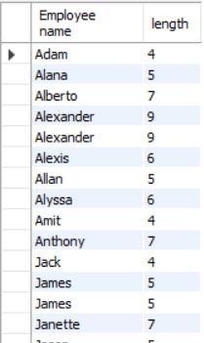

34. Write a query to display the first name and salary for all employees. Format the salary to be 10 characters long, left-padded with the $ symbol. Label the column SALARY

Query:

select first_name,lpad(salary,10,'$')"SALARY" from employees;

Output:

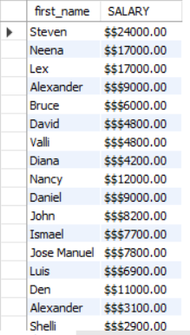

35.

Write a query to display the first eight characters of the employees' first names and indicates the amounts of their salaries with '$' sign. Each '$' sign signifies a thousand dollars. Sort the data in descending order of salary

Query:

select left(first_name,8),repeat('$',floor(salary/1000))'SALARY'FROM employees order by salary desc;

Output:

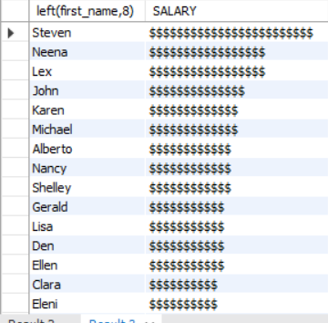

36. Write a query to display the employees with their code, first name, last name and hire date who hired either on seventh day of any month or seventh month in any year

Query:

select employee_id,first_name,last_name,hire_date from employees where position("07" in date_format(hire_date,'%d %m %y'))>0;

output:

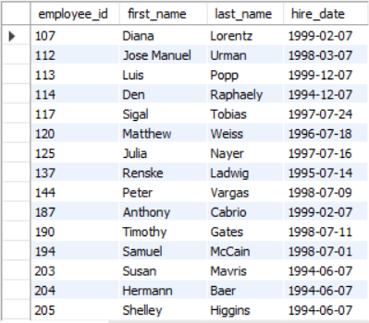

**NORTHWIND DATABASE EXERCISE**

1. Write a query to get Product name and quantity/unit

Query:

select ProductName,QuantityPerUnit from products;

Output:

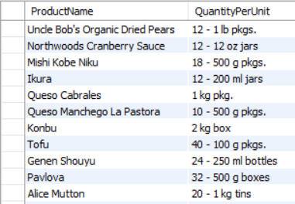

1. Write a query to get current Product list (Product ID and name)

Query:

select ProductID,ProductName from products where Discontinued ="false" order by productname;

Output:

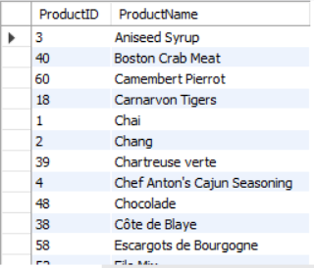

1. Write a query to get discontinued Product list (Product ID and name)

Query:

select ProductID,ProductName from products where Discontinued = 1 order by productname;

Output:

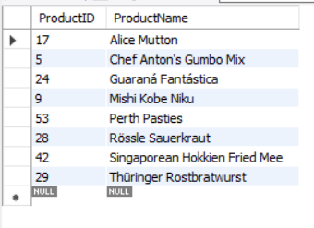

1. Write a query to get most expense and least expensive Product list (name and unit price)

Query:

select ProductName,UnitPrice from products order by UnitPrice;

Output:

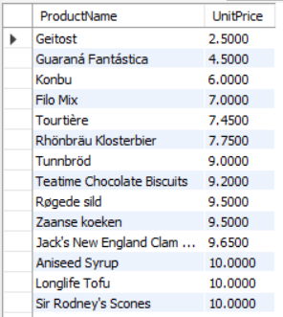

1. Write a query to get Product list (id, name, unit price) where current products cost less than $20

Query:

select ProductID,ProductName,UnitPrice from products where ((UnitPrice)<20) and ((Discontinued)= false) order by unitprice desc;

Output:

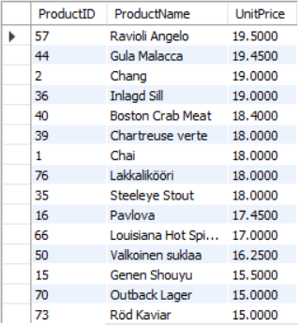

1. Write a query to get Product list (id, name, unit price) where products cost between $15 and $25

Query 1:

select productid,productname,unitprice from products where unitprice between "15" and "25" order by unitprice desc;

Output:

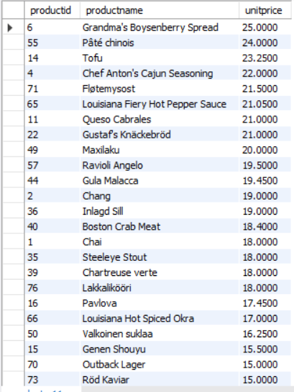

Query:

select productid,productname,unitprice from products where ((unitprice)>=15 and (unitprice)<=25) and ((products.Discontinued)=false) order by products.unitprice desc;

Output:



1. Write a query to get Product list (name, unit price) of above average price

Query:

select distinct productname,unitprice from products where unitprice > (select avg(unitprice) from products) order by unitprice;

Output:

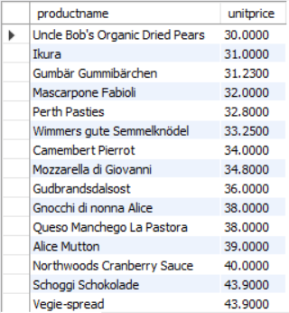

1. Write a query to get Product list (name, unit price) of ten most expensive products

Query:

select distinct ProductName,unitprice from products order by unitprice desc limit 10;

Output:

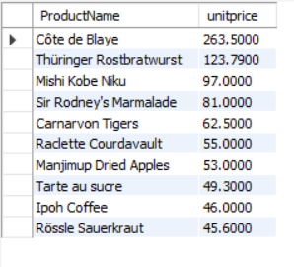

1. Write a query to count current and discontinued products

Query:

select count(productname) from products group by Discontinued;

Output:

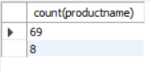

1. Write a query to get Product list (name, units on order , units in stock) of stock is less than the quantity on order

Query:

select ProductName,UnitsOnOrder,UnitsInStock from products where ((Discontinued="false") and ((UnitsInStock) < UnitsOnOrder));

Output:

